1.2实验电路结构图



图3 实验电路结构图NO.0 图4 实验电路结构图NO.1



图5 实验电路结构图NO.2 图6 实验电路结构图NO.3

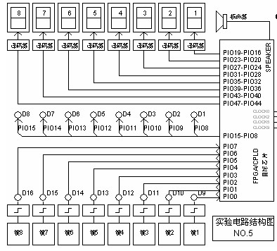

图7 实验电路结构图NO.4 图8 实验电路结构图NO.5



图9 实验电路结构图NO.6 图10 实验电路结构图NO.7

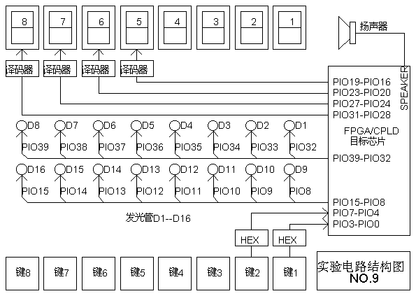

图11 实验电路结构图NO.8 图12 实验电路结构图NO.9

1.3 **FPGA核心板扩展至康芯主系统引脚对照表**

|  |  |  |  |  |  |  |  |  |
| --- | --- | --- | --- | --- | --- | --- | --- | --- |
| 结构图上的信号名 | KX-4CE6/10 | DE0  E3C16F484C6N  CycloneIII | DE0-CV  EP5CEBA4F23C7N  CycloneV | DE1-SOC  EP5CSEMA5F31C6N  CycloneV | KX-3C40  EP3C40Q240C8N  CycloneIII | 2组40芯端口名 | KX-4CE55 |  |
| 引脚号 | 引脚号 | 引脚号 | 引脚号 | 引脚号 |  | 引脚号 |  |
| PIO0 | 52 | U7 | T15 | AJ21 | 88 | DB31 | N1 |  |
| PIO1 | 55 | W6 | T18 | AG20 | 94 | DB29 | R1 |  |
| PIO2 | 64 | V8 | T20 | AG21 | 103 | DB27 | V1 |  |
| PIO3 | 66 | W10 | R17 | AF21 | 107 | DB25 | Y1 |  |
| PIO4 | 67 | V11 | P18 | AE19 | 113 | DB23 | AB3 |  |
| PIO5 | 75 | V12 | K17 | AD20 | 131 | DB21 | AA6 |  |
| PIO6 | 34 | W13 | L17 | AK21 | 133 | DB19 | Y7 |  |
| PIO7 | 84 | U14 | M18 | AJ20 | 135 | DB17 | AB6 |  |
| PIO8 | 60 | T8 | R16 | AF19 | 106 | DB26 | U2 |  |
| PIO9 | 65 | Y10 | R15 | AF20 | 112 | DB24 | W2 |  |
| PIO10 | 70 | R10 | K19 | AE18 | 114 | DB22 | AA3 |  |
| PIO11 | 74 | U13 | L19 | AD19 | 132 | DB20 | AB5 |  |
| PIO12 | 77 | Y13 | L18 | AH20 | 134 | DB18 | W6 |  |
| PIO13 | 83 | V14 | P16 | AH19 | 137 | DB16 | W8 |  |
| PIO14 | 42 | V7 | K16 | AC22 | 70 | DA31 | P1 |  |
| PIO15 | 39 | V6 | J17 | AA20 | 73 | DA30 | N2 |  |
| PIO16 | 44 | U8 | G12 | AD21 | 76 | DA29 | U1 |  |
| PIO17 | 43 | Y7 | G13 | AE22 | 78 | DA28 | R2 |  |
| PIO18 | 49 | T9 | G15 | AF23 | 80 | DA27 | W1 |  |
| PIO19 | 46 | U9 | G16 | AF24 | 81 | DA26 | V2 |  |
| PIO20 | 51 | T10 | F12 | AG22 | 82 | DA25 | AA1 |  |
| PIO21 | 50 | U10 | F13 | AH22 | 83 | DA24 | Y2 |  |
| PIO22 | 59 | R12 | F15 | AJ22 | 84 | DA23 | AA5 |  |
| PIO23 | 54 | R11 | F14 | AK22 | 87 | DA22 | AA4 |  |
| PIO24 | 69 | T12 | E16 | AH23 | 98 | DA21 | Y6 |  |
| PIO25 | 68 | U12 | E15 | AK23 | 100 | DA20 | V6 |  |
| PIO26 | 72 | R14 | E14 | AG23 | 99 | DA19 | Y8 |  |
| PIO27 | 71 | T14 | C15 | AK24 | 110 | DA18 | W7 |  |
| PIO28 | 76 | AB7 | B15 | AJ24 | 111 | DA17 | AB7 |  |
| PIO29 | 73 | AA7 | A14 | AJ25 | 128 | DA16 | AA7 |  |
| PIO30 | 85 | AA9 | L8 | AH25 | 127 | DA15 | AB9 |  |
| PIO31 | 80 | T16 | J13 | AK26 | 126 | DAT1 | AA9 |  |
| PIO32 | 101 | AB9 | A15 | AJ26 | 118 | DA14 | V11 |  |
| PIO33 | 100 | R16 | H14 | AK27 | 117 | DAT0 | Y10 |  |
| PIO34 | 113 | V15 | J11 | AK28 | 160 | DA13 | AB14 |  |
| PIO35 | 105 | W15 | H10 | AK29 | 159 | DA12 | AA13 |  |
| PIO36 | 120 | T15 | G11 | AJ27 | 166 | DA11 | T16 |  |
| PIO37 | 114 | U15 | J19 | AH27 | 164 | DA10 | AA15 |  |
| PIO38 | 128 | W17 | J18 | AH24 | 176 | DA9 | W17 |  |
| PIO39 | 125 | Y17 | H18 | AG26 | 173 | DA8 | Y17 |  |
| PIO40 | 135 | AB17 | G17 | AG25 | 195 | DA7 | AB16 |  |
| PIO41 | 136 | AA17 | G18 | AF26 | 194 | DA6 | AA16 |  |
| PIO42 | 137 | AA18 | D13 | AF25 | 197 | DA5 | U20 |  |
| PIO43 | 138 | AB18 | C13 | AE24 | 196 | DA4 | AB18 |  |
| PIO44 | 141 | AB19 | B13 | AE23 | 201 | DA3 | AA19 |  |
| PIO45 | 142 | AA19 | A13 | AD24 | 200 | DA2 | AB19 |  |
| PIO46 | 143 | AB20 | B12 | AC23 | 202 | DA1 | U21 |  |
| PIO47 | 144 | AA20 | A12 | AA21 | 203 | DA0 | U22 |  |
| PIO48 | 58 | W7 | T19 | AF18 | 95 | DB28 | P2 |  |
| PIO49 | 53 | V5 | T17 | AG18 | 93 | DB30 | M2 |  |
| CLKB0 | 90 | AB12 | N16 | AC18 | 149 | CLKB0 | W22 |  |
| CLKB1 | 91 | AA12 | M16 | AD17 | 150 | CLKB1 | W21 |  |
| **8051/88** |  |  |  |  |  |  |  |  |
| MT | 88 | AB11 | H16 | AB17 | 151 | CLKA0 | V22 |  |
| NO | 89 | AA11 | H15 | AB21 | 152 | CLKA1 | V21 |  |
| PE0 | 127 | AA15 | D17 | AK16 | 186 | DB2 | AA21 |  |
| PE2 | 124 | AA14 | K21 | AK19 | 184 | DB4 | W20 |  |
|  | 133 | AB16 | B16 | Y17 | 189 | DB0 | Y22 |  |
|  | 129 | AA16 | C16 | Y18 | 188 | DB1 | Y21 |  |
|  | 126 | AB15 | K20 | AK18 | 187 | DB3 | AA20 |  |
|  | 121 | AB14 | K22 | AJ19 | 185 | DB5 | AB20 |  |
|  | 119 | AB13 | M20 | AJ17 | 177 | DB6 | AA17 |  |
|  | 115 | AA13 | M21 | AJ16 | 183 | DB7 | AB17 |  |
|  | 111 | AB10 | N21 | AH18 | 171 | DB8 | V16 |  |
|  | 112 | AA10 | R22 | AH17 | 169 | DB9 | U16 |  |
|  | 106 | AB8 | R21 | AG16 | 162 | DB10 | AA14 |  |
|  | 110 | AA8 | T22 | AE16 | 161 | DB11 | AB15 |  |
|  | 103 | AB5 | N20 | AF16 | 146 | DB12 | Y13 |  |
|  | 104 | AA5 | N19 | AG17 | 145 | DB13 | AB13 |  |
|  | 98 | AB3 | M22 | AA18 | 144 | DBT0 | AA10 |  |
|  | 99 | AB4 | P19 | AA19 | 143 | DB14 | AB10 |  |
|  | 86 | AA3 | L22 | AE17 | 142 | DBT1 | AA8 |  |
|  | 87 | AA4 | P17 | AC20 | 139 | DB15 | AB8 |  |